DriverPass System Design Document

CS 255 – System Analysis and Design
Shawn Ward
Southern New Hampshire University
Professor Dr. Goodman
16 April 2026

CS 255 System Design Document

This template lays out all the different sections that you need to complete for Project Two. Each section has guidance to prompt your thinking. You will need to continually reference the interview transcript as you work to make sure that you are addressing your client’s needs. There is no required length for the final document. Instead the goal is to complete each section based on what your client’s needs are. Remove this note when you are finished, and replace all bracketed text with the relevant information.

UML Diagrams

UML Use Case Diagram
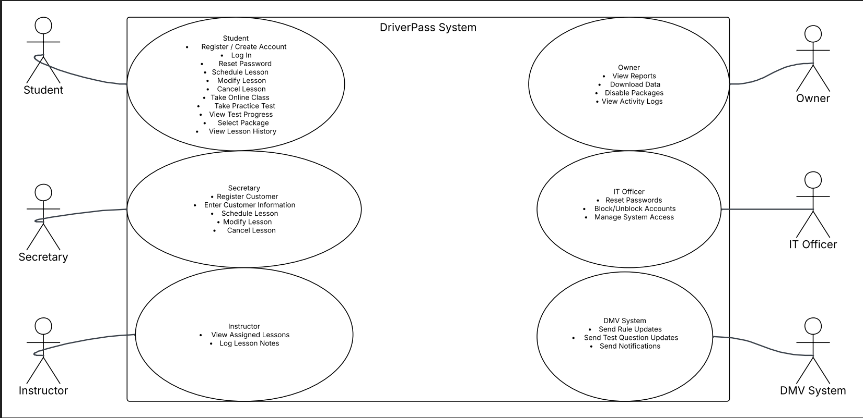
Fig 1 : Driver Pass UML Diagram
Explanation:
The use case diagram shows the main users of the DriverPass system and the actions each user can perform. It includes the student, instructor, secretary, IT officer, and owner. Each actor connects to the use cases that match their responsibilities. Students can register, schedule lessons, take practice tests, and reset passwords. The secretary can schedule lessons for customers who call in or visit the office. The instructor can view assigned lessons and record comments. The IT officer manages accounts and resets passwords. The owner views reports and activity logs. This diagram reflects the client requirements and shows how each user interacts with the system.

UML Activity Diagrams
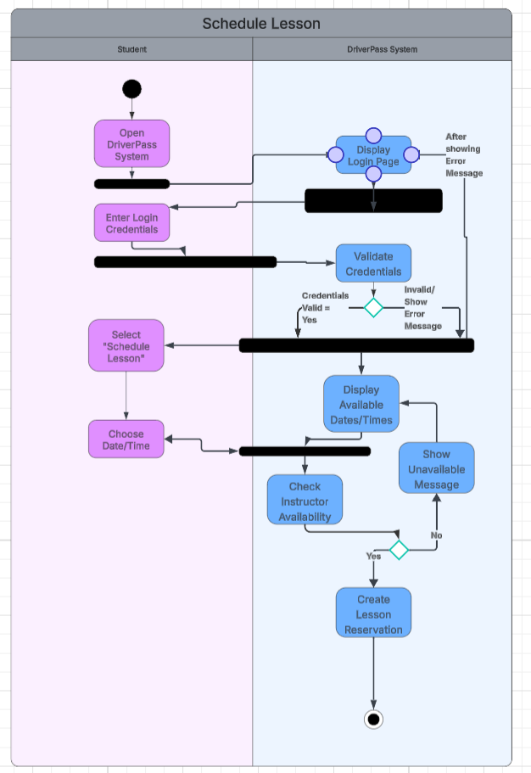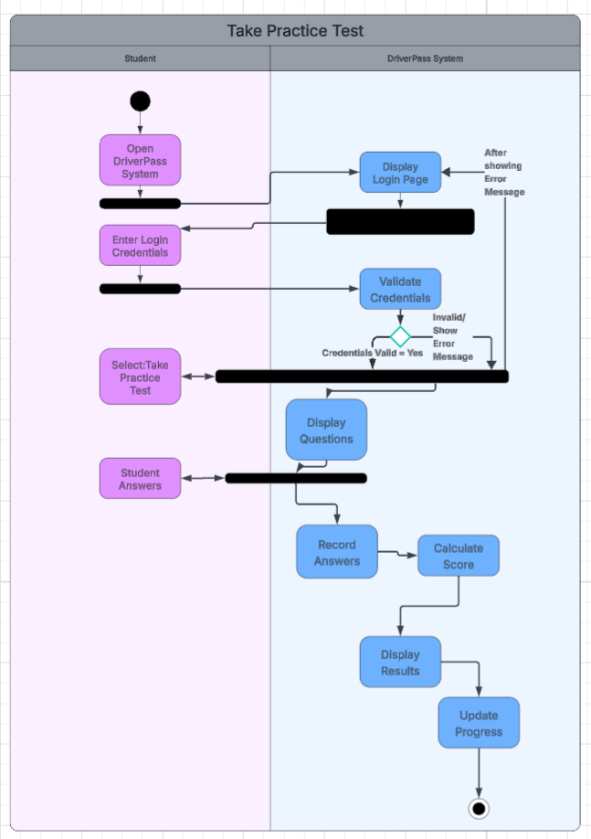
Fig 2 : Schedule Lesson Fig 3 : Take Practice Test
Explanation:
The activity diagrams show the flow of steps for each selected use case. They outline how the user begins the process, how the system responds, and how the process ends. Each decision point shows what happens when the user chooses a different option. These diagrams confirm that the system supports the full workflow from start to finish.

UML Sequence Diagram
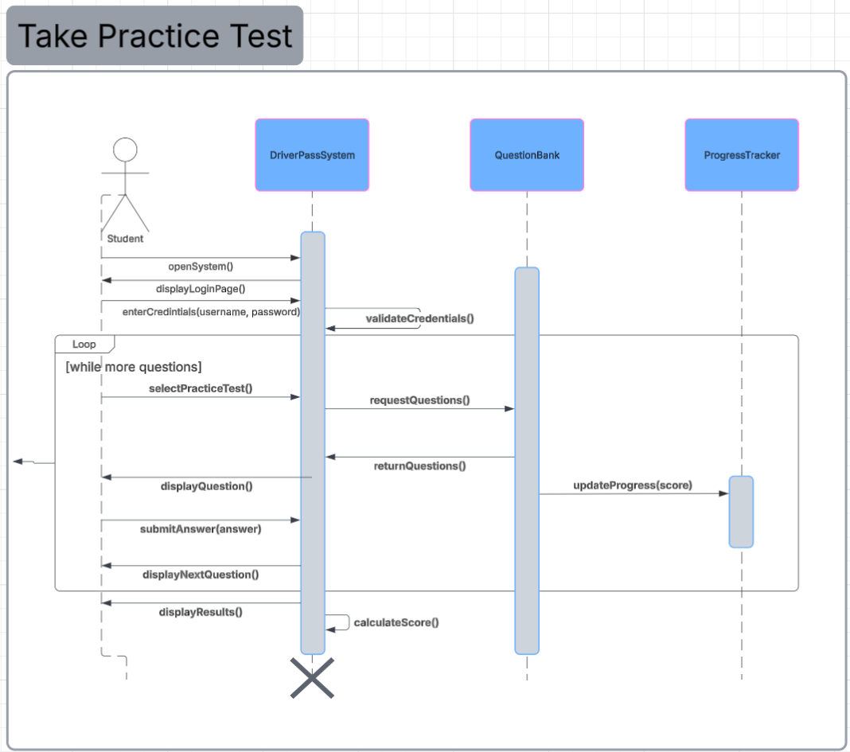
Fig 4 : UML Sequence Diagram

Explanation:

The sequence diagram shows how the student interacts with the system during the practice test process. It includes the student, the DriverPass system, the practice test component, and the progress tracker. The diagram shows the order of messages, how the system retrieves questions, records answers, calculates the score, and updates progress. This supports the client requirement for online practice tests and accurate progress tracking.

UML Class Diagram
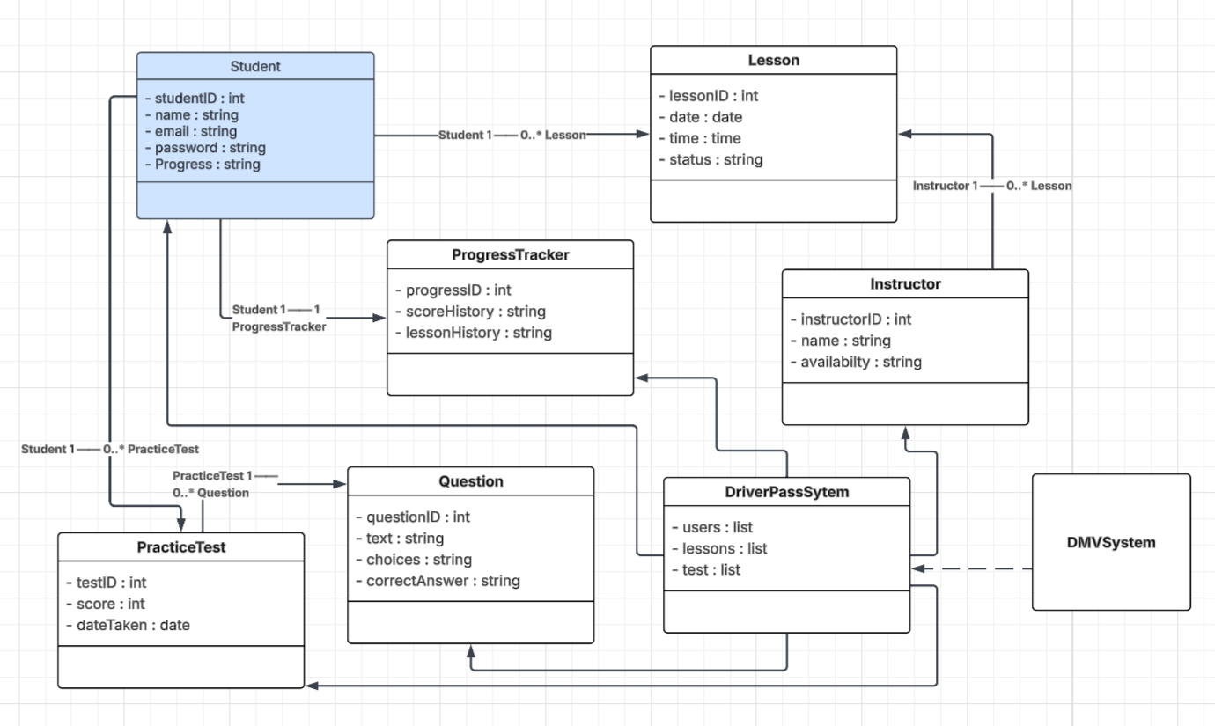
Fig 5 : UML Class Diagram
Explanation:
The class diagram shows the main parts of the DriverPass system and how they relate to each other. It includes classes for Student, Lesson, Instructor, PracticeTest, Question, ProgressTracker, DriverPassSystem, and DMVSystem. Each class contains the attributes needed to support scheduling, online tests, progress tracking, and DMV updates. The multiplicities show how many objects can be linked. For example, a student can have many lessons and many practice tests, while each student has one progress tracker. The DMVSystem connects to the DriverPassSystem to provide updated rules and questions. This design meets all client requirements.

Technical Requirements

Based on the system design and UML diagrams, the DriverPass system requires a cloud‑based, web‑accessible infrastructure that supports online training, scheduling, reporting, and DMV integration. The following hardware, software, tools, and infrastructure components are necessary to implement the system:
Hardware Requirements
- Cloud‑hosted servers (virtual machines or managed compute instances) to run the application and database
- Secure storage for user data, lesson schedules, test questions, and progress tracking
- End‑user devices such as desktops, laptops, tablets, and mobile phones capable of running a modern web browser
- Reliable internet connectivity for all users, including customers, instructors, the secretary, and administrative staff
Software Requirements
- A web‑based application built using modern web technologies (HTML, CSS, JavaScript, and a server‑side framework such as Java, C#, Python, or Node.js)
- A relational database management system (e.g., MySQL, PostgreSQL, SQL Server) to store user accounts, lessons, instructors, practice tests, and progress data
- Authentication and authorization software to support role‑based access control for the owner, IT officer, secretary, instructors, and students
- Reporting tools capable of exporting data to Excel formats (CSV or XLSX)
- Notification services to alert the system when DMV updates occur
Infrastructure Requirements
- Cloud hosting platform (AWS, Azure, or Google Cloud) to provide scalability, automatic backups, and security management
- Secure API connection to the DMV system for receiving updated rules, policies, and test questions
- Encrypted data transmission using HTTPS/TLS to protect sensitive information such as passwords and scheduling data
- Secure storage and encryption for user credentials and activity logs
- Backup and disaster recovery services provided by the cloud platform
- Logging and auditing tools to track who created, modified, or canceled reservations
Tools and Development Requirements
- UML modeling tools such as Lucidchart for creating use case, activity, sequence, and class diagrams
- Version control system (e.g., GitHub or Azure DevOps) for managing source code
- Integrated development environment (IDE) such as Visual Studio, IntelliJ, or VS Code
- Testing tools for functional, security, and integration testing
- Project management tools for scheduling tasks and maintaining the Gantt chart
System Constraints
- Users may access data offline for viewing, but modifications cannot be made offline to prevent data redundancy
- The system must support multiple user roles with different permissions
- The system must be flexible enough to disable training packages without removing them from the database
- The system must run entirely through a web interface with no local installation required

